Looping Statement
Q1.
package LoopingAssignment;

public class Q1IfStatement {

public static void main(String[] args) {
int num=80;//93
if((num % 3==0 && num % 5!=0 && num>=50 && num<=200))
{
System.out.println("valid");
}
System.out.println("invalid");
}

}

Output:

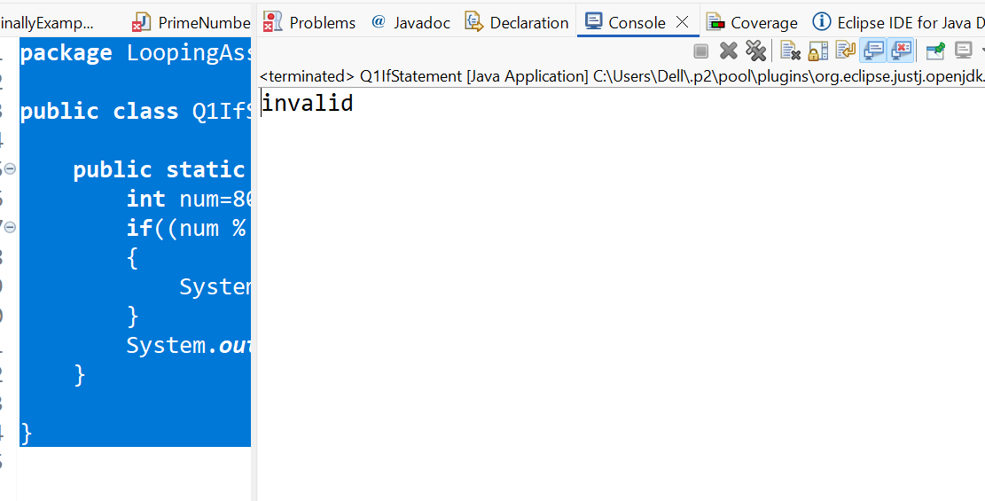
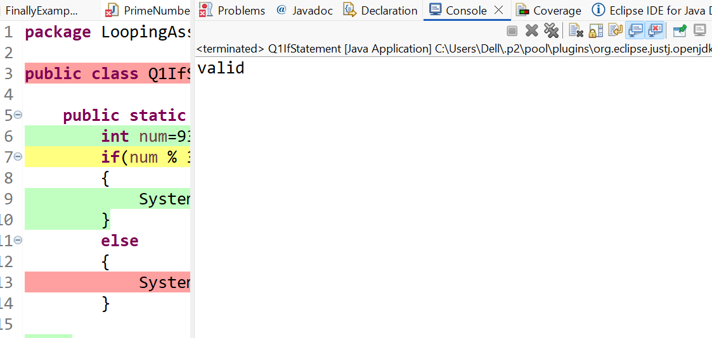

Q2.
package LoopingAssignment;

public class Q2LargestNumber {

public static void main(String[] args) {
int a=40;
int b=20;
int c=30;
if(a>=b && a<=c|| a<=b && a>=c)
{
System.out.println(a);
}
else if(b>=a && b<=c || b<=a && b>=c)
{
System.out.println(b);
}
else
{
System.out.println(c);
}

}

}
Output:
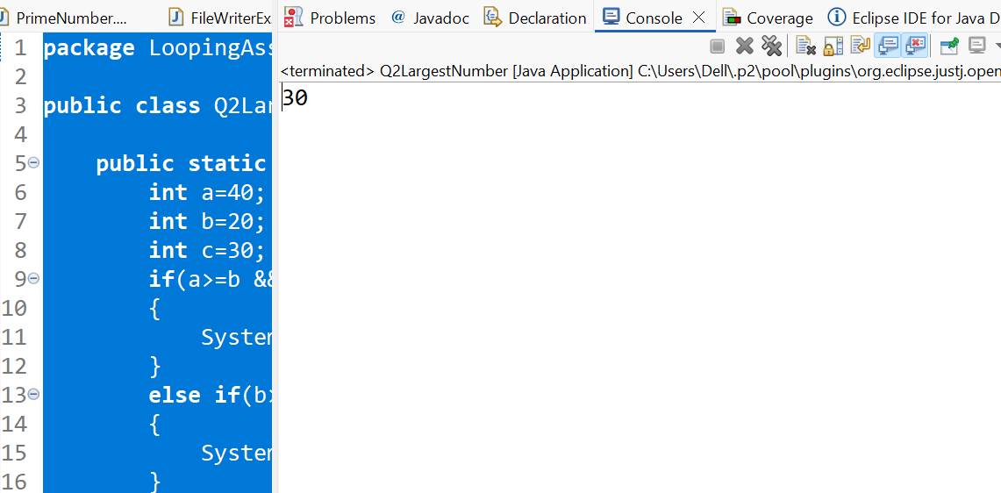
Q3.
package LoopingAssignment;

public class Q3LeapYear {

public static void main(String[] args) {
//Leap year means year which is divisible by 4 and not by 100 or divisible by 400
int year=1900;//2024
if((year % 4==0 && year % 100 !=0)||(year % 400==0))
{
System.out.println("it is a leap year");
}
else
{
System.out.println("it is not a leap year");
}
}

}
Output:
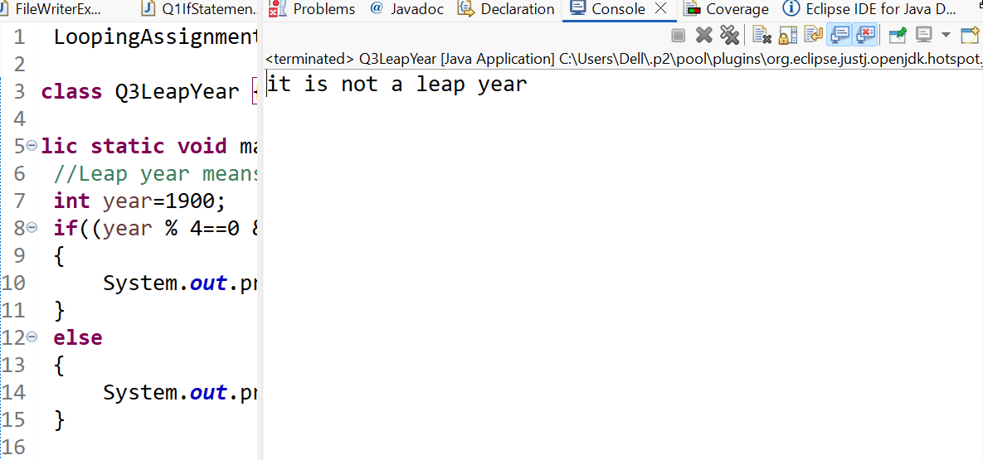
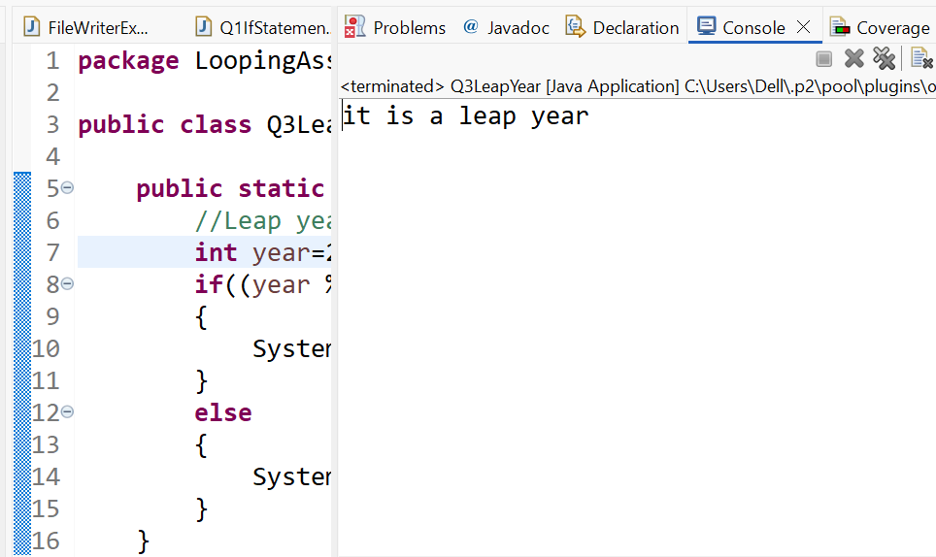
Q4.
package LoopingAssignment;

import java.util.Scanner;

public class Q4 {

public static void main(String[] args) {
Scanner sc=new Scanner(System.in);
System.out.println("Enter the number");

int num= sc.nextInt();

if((num>0 && num % 4==0)||(num<0 && num % 6==0))
{
System.out.println("It is a valid");
}
else
{
System.out.println("It is a Invalid");
}
}

}

Output:

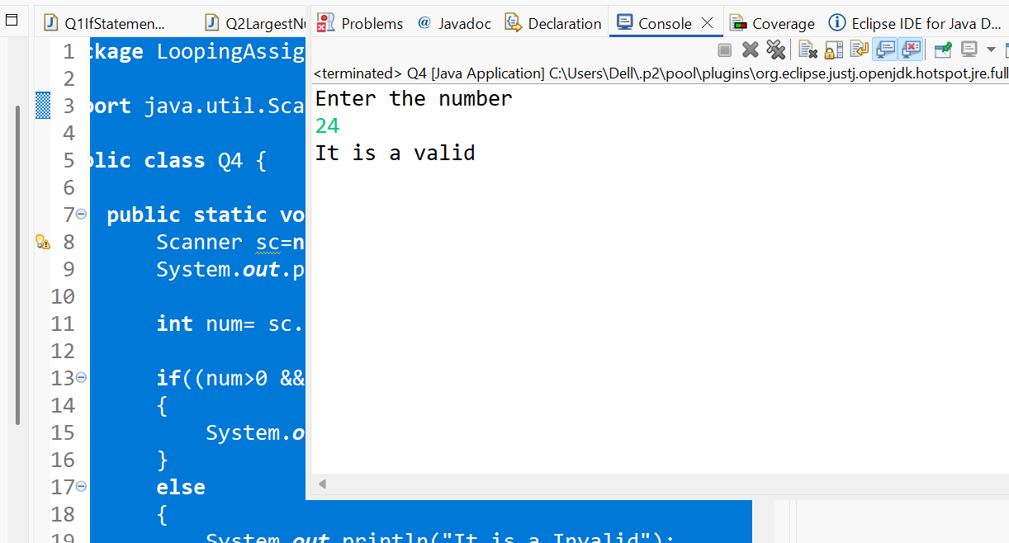
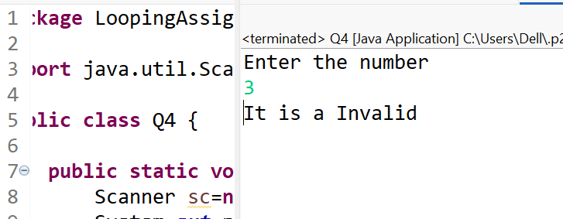
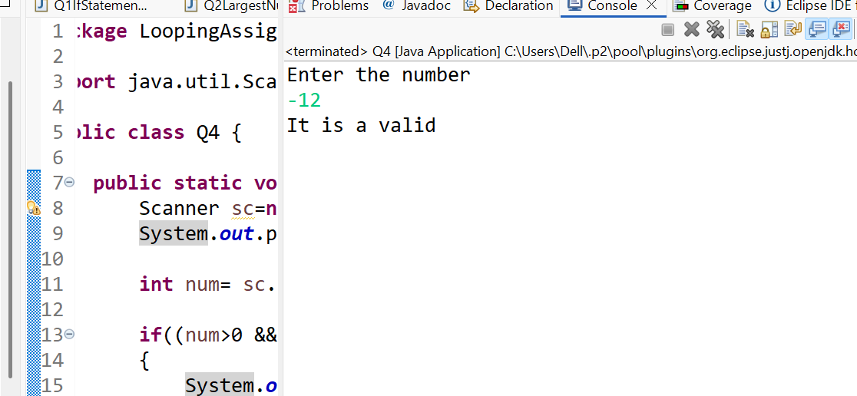
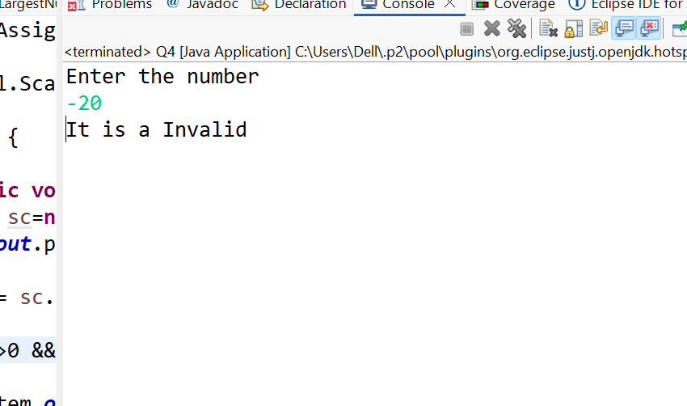

Q5.
package LoopingAssignment;

import java.util.Scanner;

public class Q5 {

public static void main(String[] args) {
Scanner sc=new Scanner(System.in);
System.out.println("Enter a number");
int num=sc.nextInt();

if(num % 2==0 && num % 3==0)
{
System.out.println("A");
}
else if(num % 3==0 && num % 2!=0)
{
System.out.println("B");
}
else if(num % 2==0 && num % 3!=0)
{
System.out.println("C");
}
else
{
System.out.println("D");
}

}

}
Output:
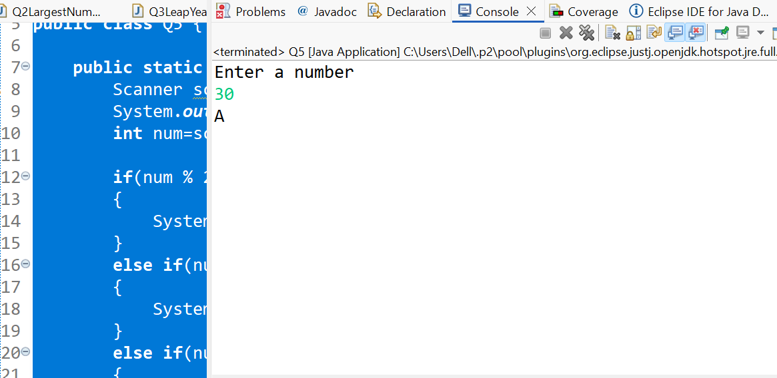
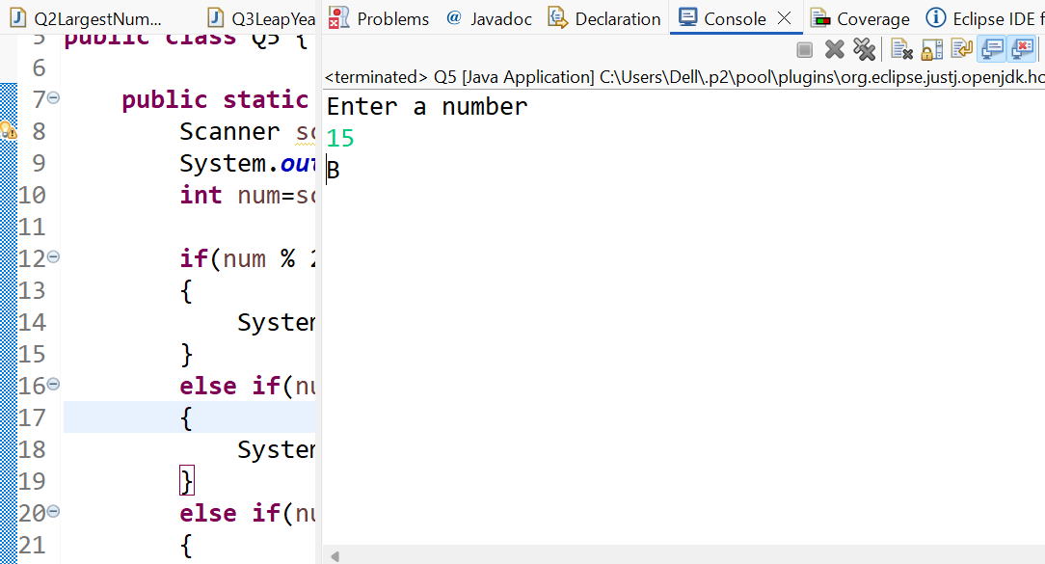
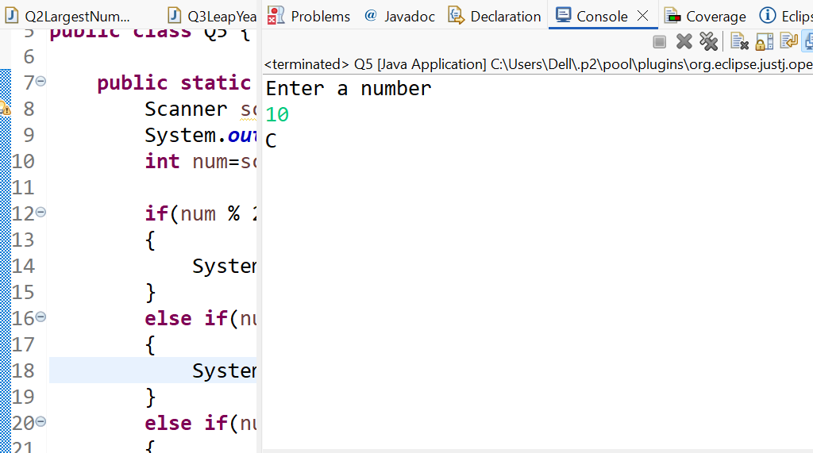
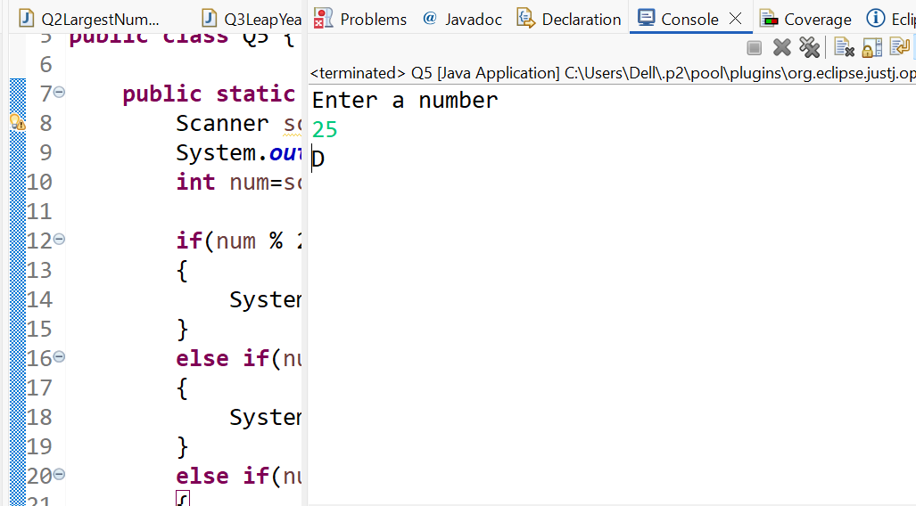

Q6:
package LoopingAssignment;

import java.util.Scanner;

public class Q6 {

public static void main(String[] args) {
int M,C,P;

Scanner sc=new Scanner(System.in);
System.out.println("Enter Physics marks");
P=sc.nextInt();

System.out.println("Enter Chemistry marks");
C=sc.nextInt();

System.out.println("Enter Maths marks");
M=sc.nextInt();

int Total=P+C+M;
int MP=M+P;

if(M>=60)
{
if(P>=50)
{
if(C>=40)
{
if(Total>=180||MP>=120)
{
System.out.println("Eligible for physics hons");
}
else
{
System.out.println("Not eligible");
}
}
else
{
System.out.println("Not eligible");
}
}
else
{
System.out.println("Not eligible");
}
}
}
}

Output:

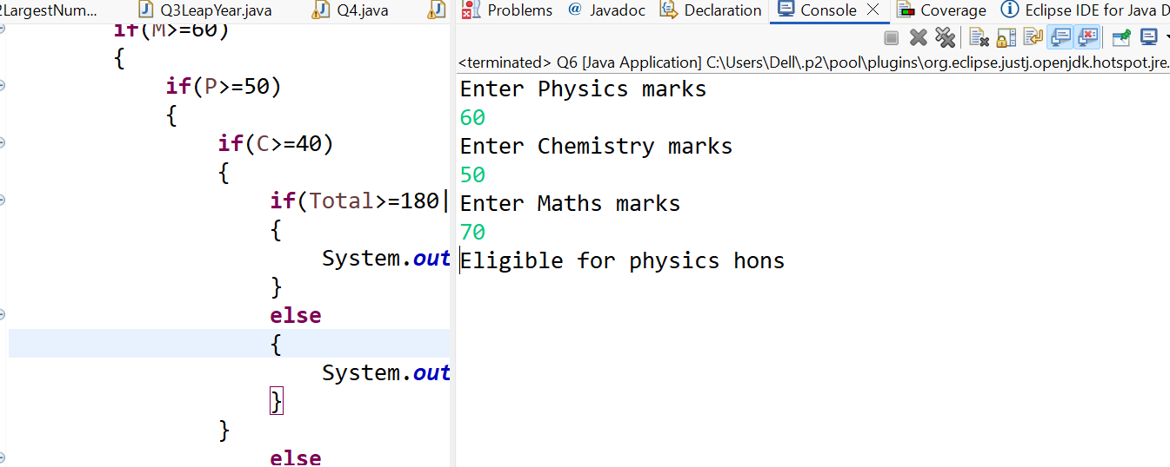

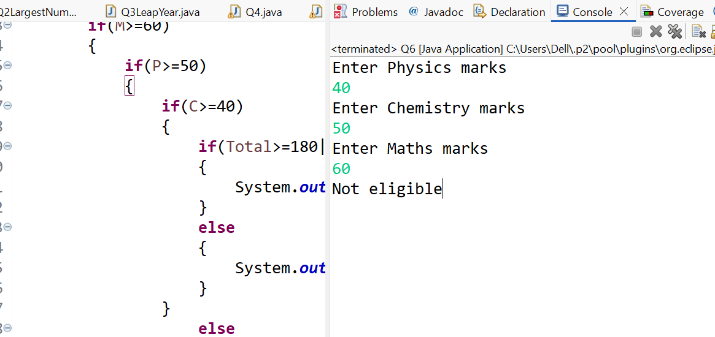

Q7.
package LoopingAssignment;

import java.util.Scanner;

public class Q7LargestNumber {

public static void main(String[] args) {

int a,b,c,d;
Scanner sc=new Scanner(System.in);
System.out.println("Enter the value of a");
a=sc.nextInt();

System.out.println("Enter the value of b");
b=sc.nextInt();

System.out.println("Enter the value of c");
c=sc.nextInt();

System.out.println("Enter the value of d");
d=sc.nextInt();

if(a>=b)
{
if(a>=c)
{
if(a>=d)
{
System.out.println("a is largest");
}
else
{
System.out.println("d is largest");
}
}
else

{
if (c >= d)
{
System.out.println("c is largest");
} else
{
System.out.println("d is largest");
}
}
}
else
{

if(b>=c)
{
if(b>=d)
{
System.out.println("b is largest");
}
else
{
System.out.println("d is largest");
}
}

else
{
if(c>=d)
{
System.out.println("c is largest");
}
else
{
System.out.println("d is largest");
}
}
}
}

}

Output:
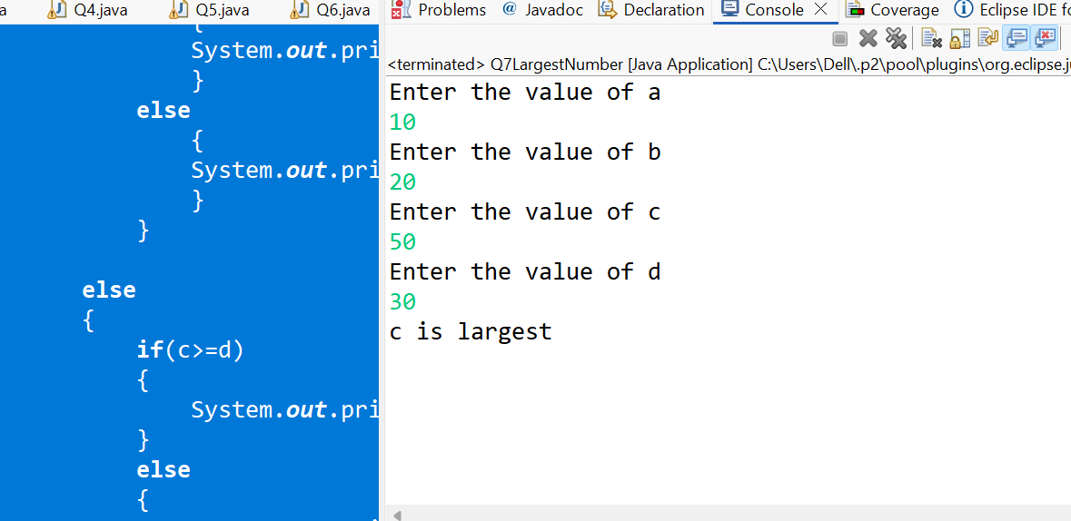

Q8.
package LoopingAssignment;

import java.util.Scanner;

public class Q8 {

public static void main(String[] args) {
int age,salary;
Scanner sc=new Scanner(System.in);
System.out.println("Enter the age");
age=sc.nextInt();

System.out.println("Enter the salary");
salary=sc.nextInt();

if(age < 25)
{
System.out.println("Not eligible");
}
else
{
if(age >= 30)
{
if(salary >= 50000)
{
System.out.println("Eligible for loan B");
}
else
{
if(salary < 30000)
{
System.out.println("Eligible for loan A");
}
else
{
System.out.println("Not eligible");
}

}
}

else

{
if(salary >= 30000)
{
System.out.println("Eligible for loan A");
}
else
{
System.out.println("Not eligible");
}
}
}
}
}

Output:

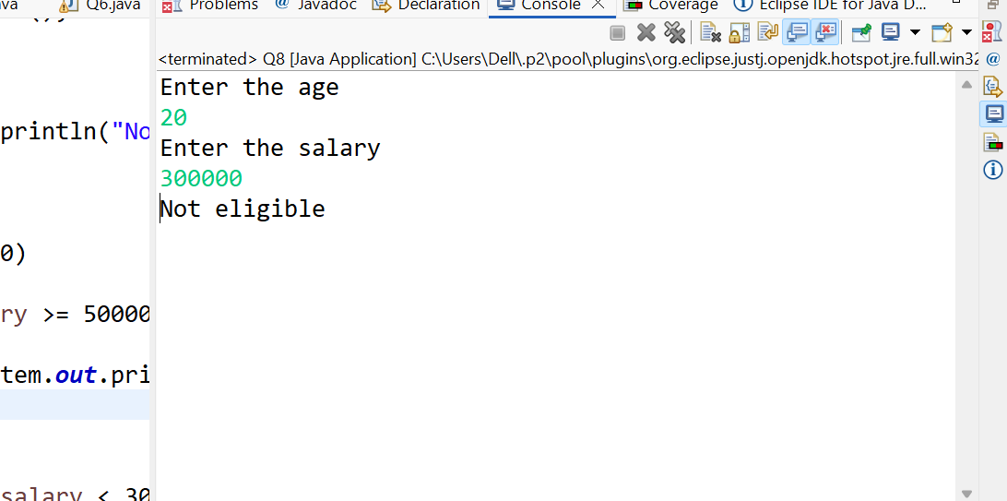

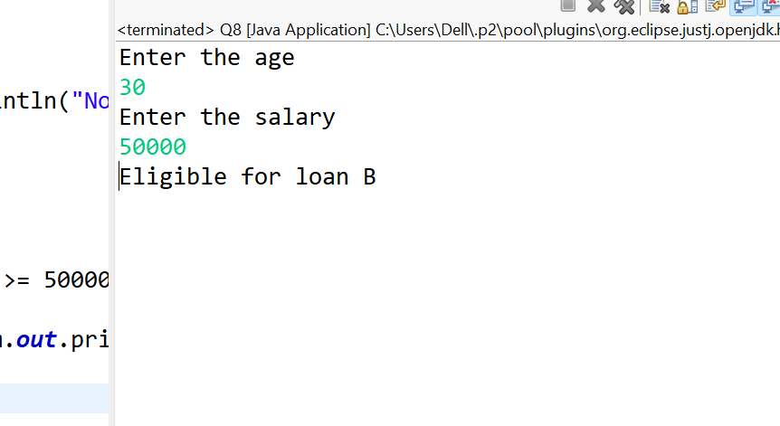

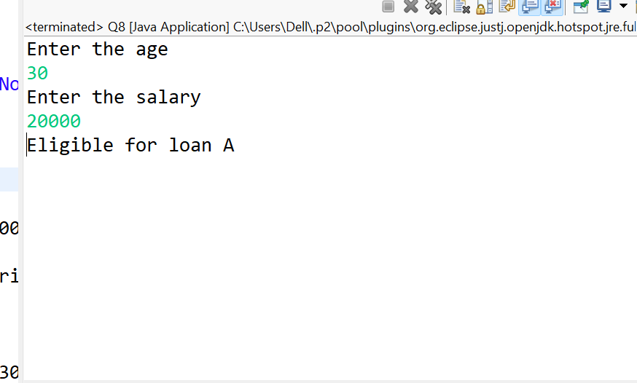

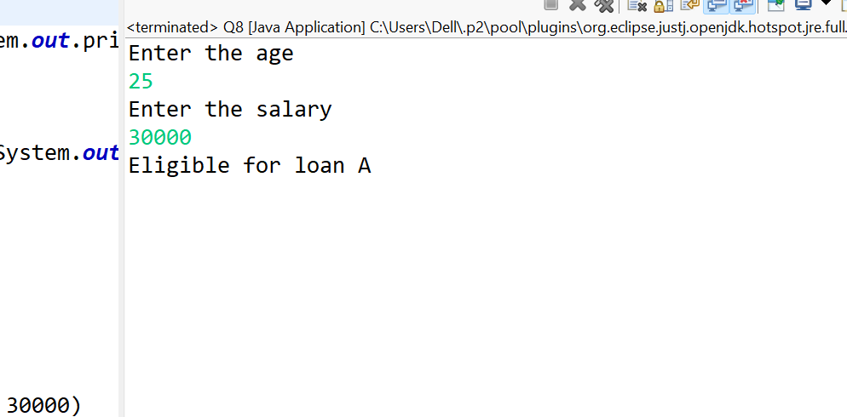

Q9

package LoopingAssignment;

import java.util.Scanner;

public class Q9 {

public static void main(String[] args) {

System.out.println("Enter the character");
Scanner sc=new Scanner(System.in);
char ch=sc.next().charAt(0);

if(ch>='A' && ch<='Z')
{
if(ch=='A'||ch=='E'||ch=='I'||ch=='O'||ch=='U')
{
System.out.println("Entered character is uppercase vowel");
}
else
{
System.out.println("Entered character is uppercase consonant");
}

}
else if(ch>='a' && ch<='z')
{
if(ch=='a'||ch=='e'||ch=='i'||ch=='0'||ch=='u')
{
System.out.println("Entered character is lowercase vowel");
}
else
{
System.out.println("Entered character is lowercase consonant");
}
}

}

}

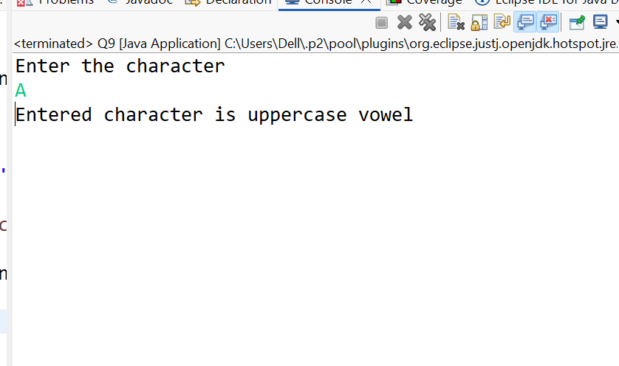

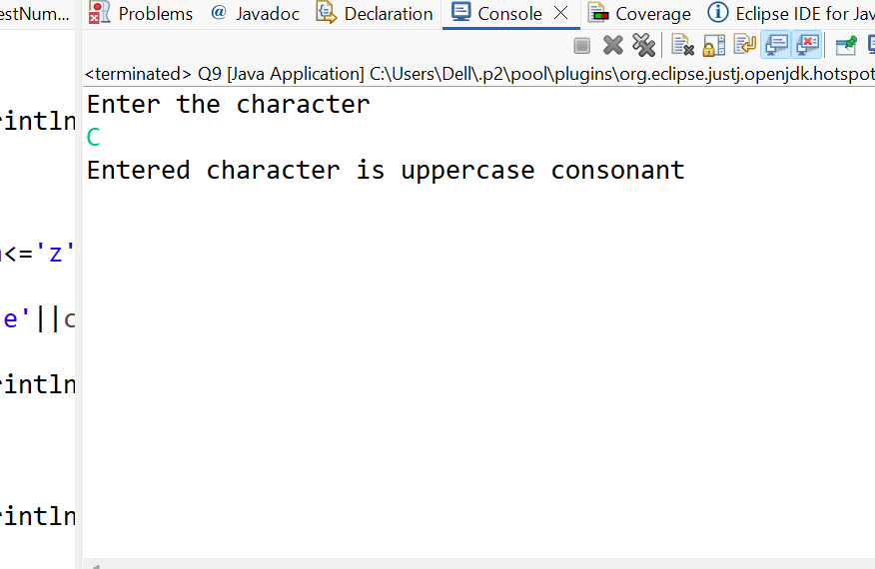

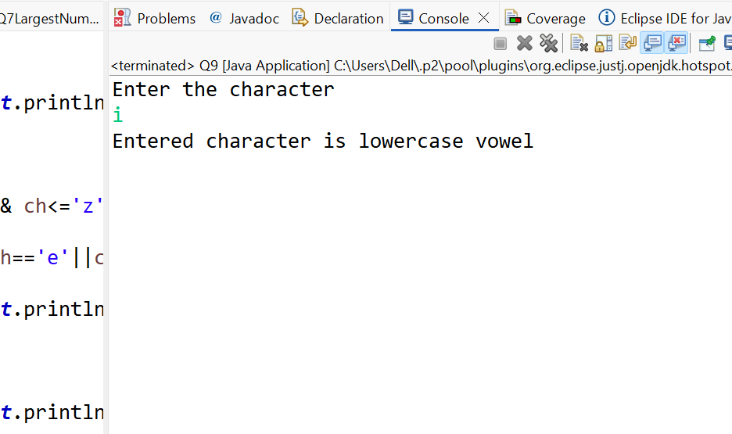

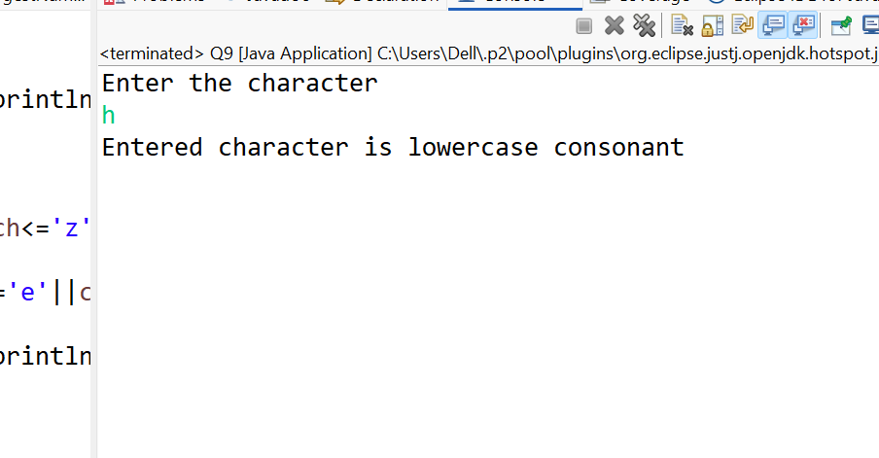

Q10.

package LoopingAssignment;

import java.util.Scanner;

public class Q10 {

public static void main(String[] args) {

System.out.println("Enter the number");
Scanner sc=new Scanner(System.in);

int num=sc.nextInt();

if(num>=100 && num<=999)
{
int sum=(num / 100)+ (num / 10) % 10+(num % 10);

if((sum % 2)==0)
{
System.out.println("Entered number is 3 digit and sum is even");
}
else
{
System.out.println("Entered number is 3 digit and sum is odd");
}
}
else
{
System.out.println("Entered number is not a 3 digit number");
}

}

}

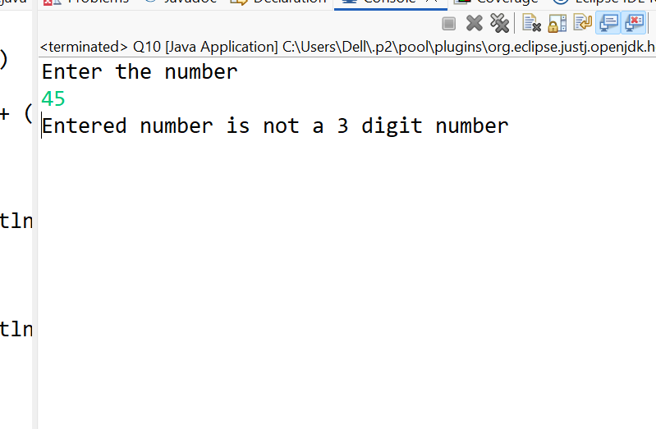
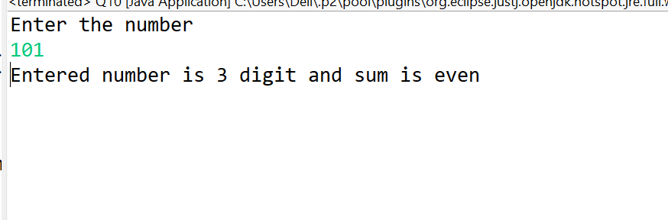

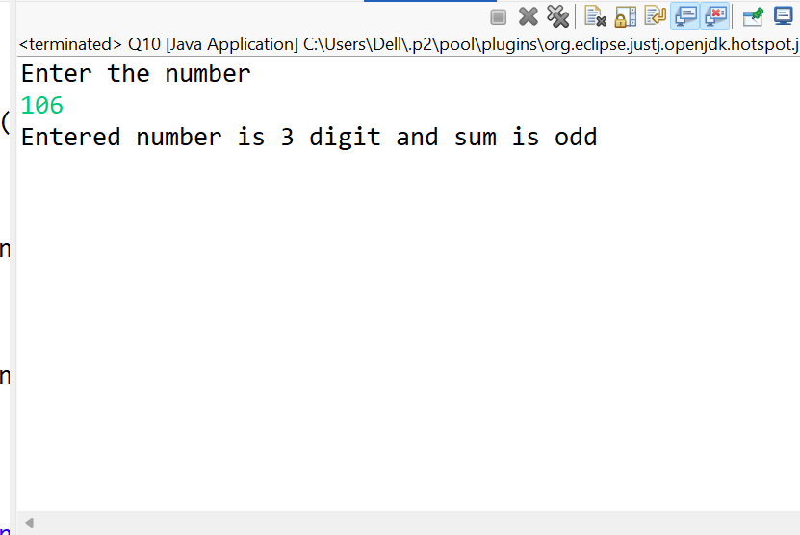

Q11

package LoopingAssignment;

public class Q11 {

public static void main(String[] args) {
int i=1;
while(i<=100)//1<=100//2<=100
{
if(i==77)//1==77 false
{
break;
}
if(i%3==0 && i%5==0) //1%3==1 1%5=1//1==1 false
{
i++;
continue;
}
System.out.println(i);//1//2
i++;//2//3
}

}

}

Output:
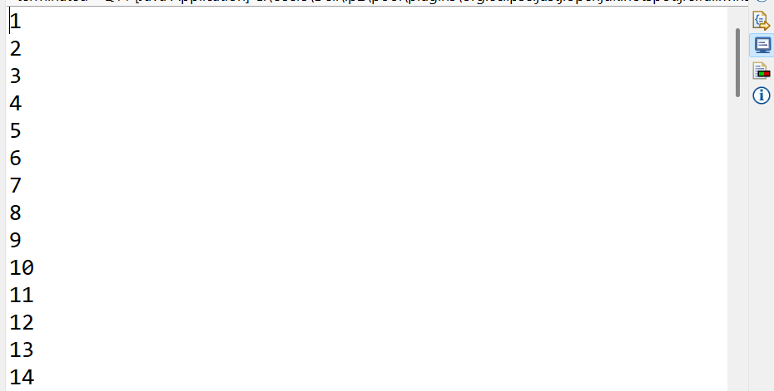
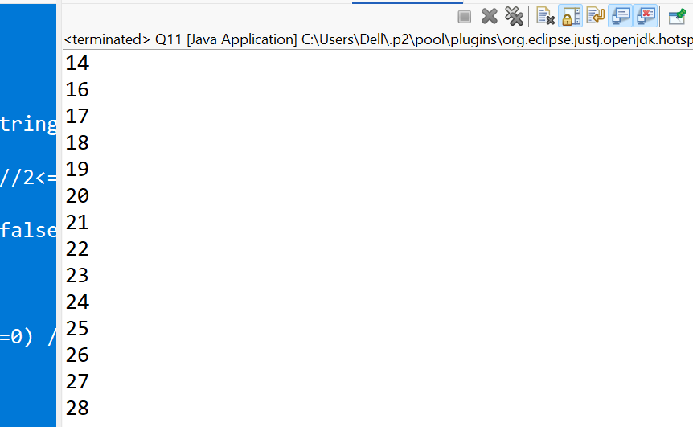

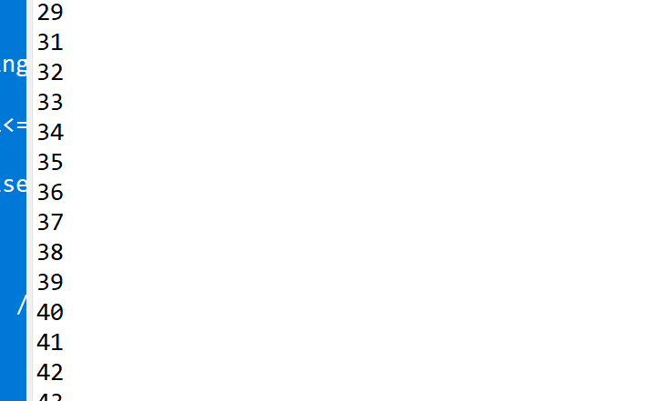
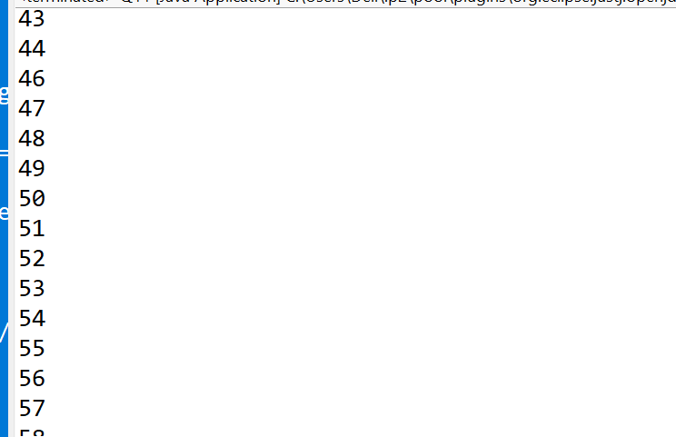
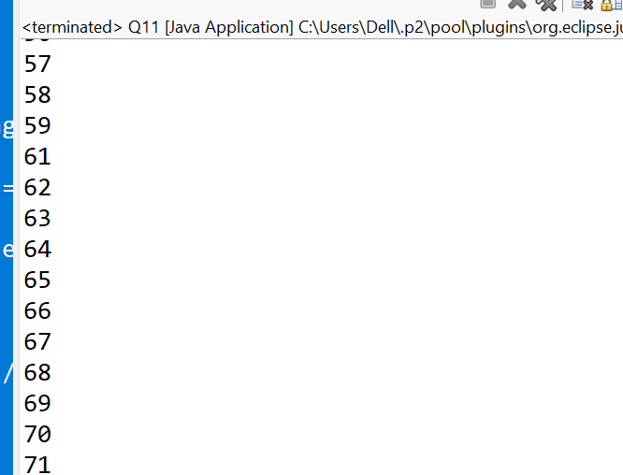
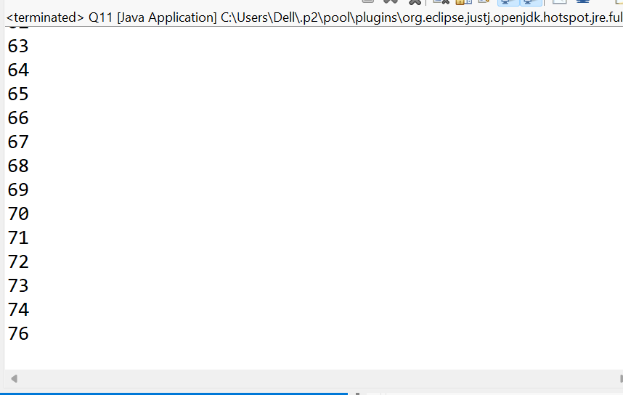

Q12
package LoopingAssignment;

import java.util.Scanner;

public class Q12 {

public static void main(String[] args) {
int rev=0;
System.out.println("Enter the number");
Scanner sc=new Scanner(System.in);
int num=sc.nextInt();//123

while(num>0)//123>0
{
int digit=num % 10;//123%10=3

if (digit==0)//3==0 f//2==0 f//1==0 f//0==0
{
break;
}
rev=rev*10+digit;//rev=0*10+3=3//rev=0*10+2=2//0*10+1=1
num=num/10;//num=123/10=12//12/10=1//1/10=0
}
System.out.println("Reverse of the number" +rev);
}

}

Output:
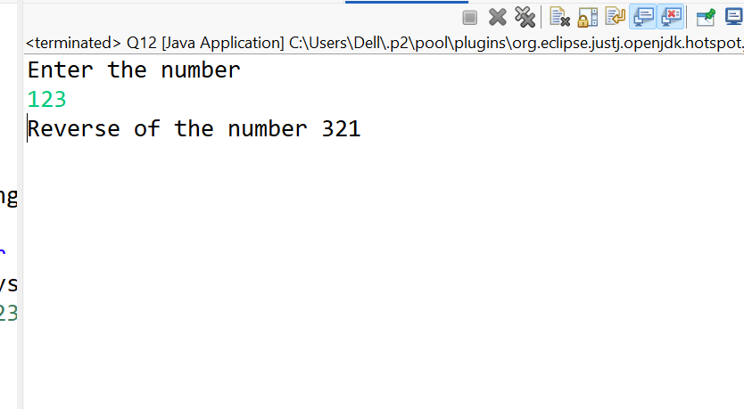

Q13.
package LoopingAssignment;

public class Q13 {

public static void main(String[] args) {

int num=5637;
int count=0;

while(num>0)//5637>0
{
int digit=num % 10;//digit=5637%10=7//563%10=3//56%10=6 f//5%10=5T

if(digit==5 || digit==3 ||digit==7)//digit=7 T//3 t//5
{
count++;//1//2//3
}
num=num/10;//num=5637/10=7//563//56//56/10=5//5/10=0
}

System.out.println("Count of prime numbers in an entered number is " +count);//3
}

}

Output:
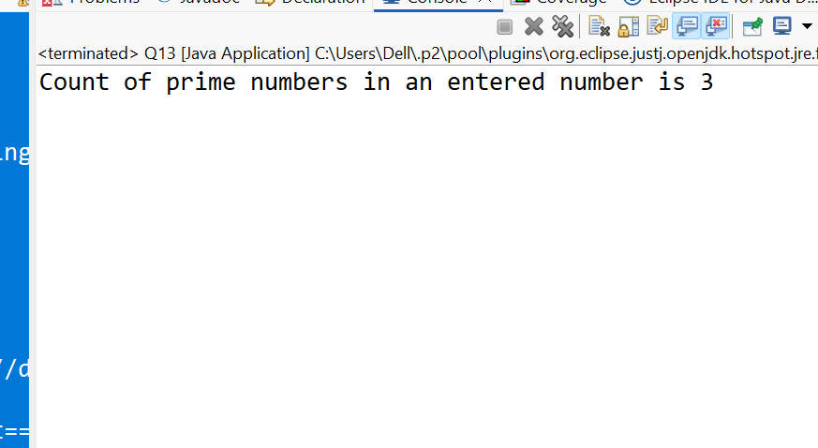

Q14.
package LoopingAssignment;

import java.util.Scanner;

public class Q14 {

public static void main(String[] args) {

System.out.println("Enter the number of terms as N");

Scanner sc=new Scanner(System.in);
int n=sc.nextInt();

int count=0;
int num1=0;
int num2=1;
while(count<n)
{
if(num1>500)
{
break;
}
System.out.println(num1 +" ");

int num3=num1+num2;
num1=num2;
num2=num3;
count++;
}

}

}
Output:
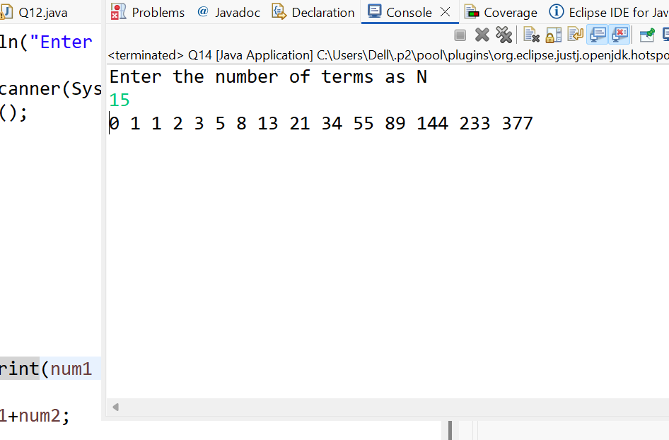
Q15
package LoopingAssignment;

import java.util.Scanner;

public class Q15 {

public static void main(String[] args) {
System.out.println("Enter the number of terms as N");
Scanner sc=new Scanner(System.in);
int n=sc.nextInt();

int count=1;
int num=1;
int value=1;

while(count<=n)//1<=15//2<=15//3<=15//4<=15
{
System.out.print(num +" ");//1//2//4//7
num=num+value;//1+1=2//2+2=4//4+3=7//7+4=11
value++;//2//3//4//
count++;//2//3//4//
}
}

}
Output:
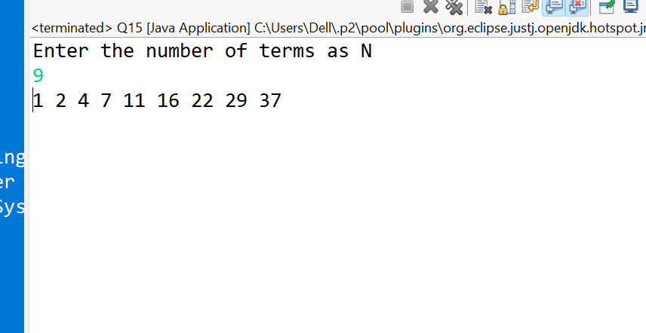
Q16:
package LoopingAssignment;

import java.util.Scanner;

public class Q16 {

public static void main(String[] args) {

int sum=0;
int num;
Scanner sc=new Scanner(System.in);

do
{
System.out.print("Enter a number : ");
num=sc.nextInt();
if(num>=0 && num%2==0)//14>=0 14%2=0//number =12 12%2 =0 //Identify even num bers
{
sum=sum+num;//0+14=14//14+12=26 //Adding even numbers
}
}while(num>=0);//14>=0 //Loop stop when negative number entered

System.out.println("Sum of even numbers : " + sum);
sc.close();

}

}

Output:
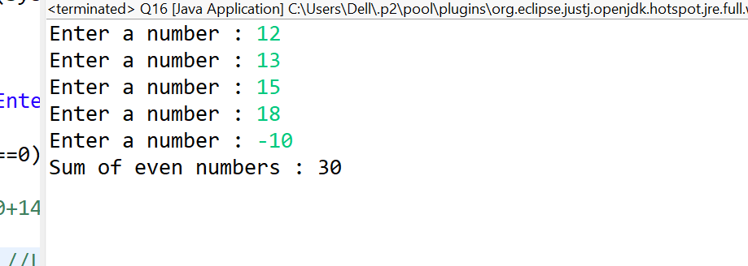

Q17.
package LoopingAssignment;

import java.util.Scanner;

public class Q17 {

public static void main(String[] args) {
//Revers of number using do while

int num;
int rev=0;

System.out.println("Enter a number : ");
Scanner sc=new Scanner(System.in);
num=sc.nextInt();
//First reverse the number and then print left to right

//Reverse the number
do
{
int d=num%10;//128%10=8//12%10=2//1%10=1//
rev=rev*10+d;//rev=0*10+8=8//0*10+2==2//0*10+1=1
num=num/10;//128/10=12//12/10=1//1/10=0

}while(num!=0);
//System.out.println(rev);

//Print digit from left to write
do
{
int d=rev%10;//821%10=1//82%10=2//8%10=8

System.out.print(d + " ");//1//2//8
rev=rev/10;//821/10=82//82/10=8//

}while(rev!=0);

}

}
Output:
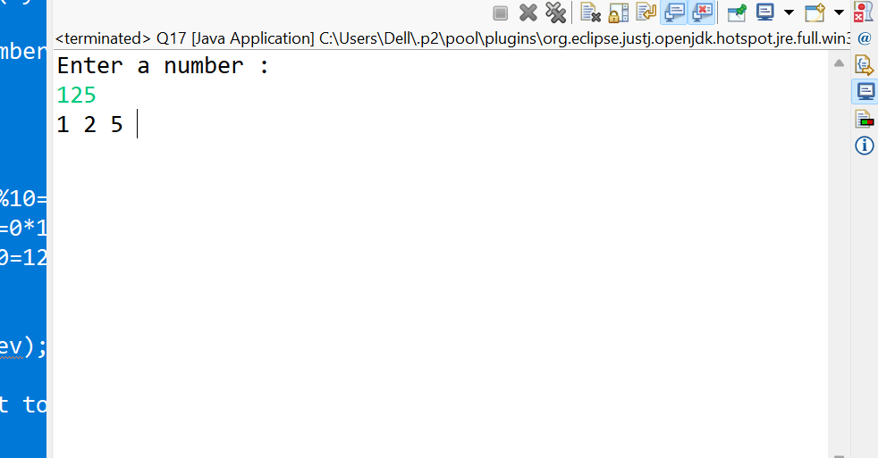

Q18.
package LoopingAssignment;

public class Q18 {

public static void main(String[] args) {
int a=5;

do
{
System.out.println("Loop executed");
}while(a < 0);

}

}
Output:
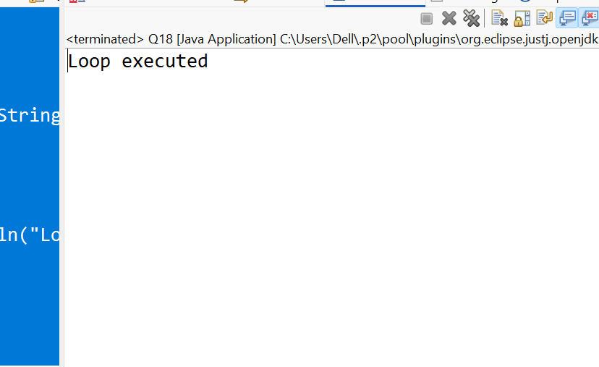

Q19.
package LoopingAssignment;

import java.util.Scanner;

public class Q19 {

public static void main(String[] args) {
int num1;
int num2;
int choice=0;
int Result;
Scanner sc=new Scanner(System.in);
do
{
System.out.println("****Menu driven*****");
System.out.println("1. Add ");
System.out.println("2. Subtract ");
System.out.println("3. Multiplication");
System.out.println("4. Exit ");
System.out.println("Enter your choice");

choice=sc.nextInt();
if(choice>=1 && choice<=3)
{
System.out.println("Enter first number : ");
num1=sc.nextInt();

System.out.println("Enter second number : ");
num2=sc.nextInt();

if(choice==1)
{
Result=num1 + num2;
System.out.println(Result);
}
else if(choice==2)
{
Result=num1 - num2;
System.out.println(Result);
}
else if(choice==3)
{
Result=num1 * num2;
System.out.println(Result);
}
}
else if(choice==4)
{
System.out.println("Exit from program ");
break;
}
else
{
System.out.println("invalid choice, Try again");
}

}while(choice!=4);

sc.close();
}
}

Output:
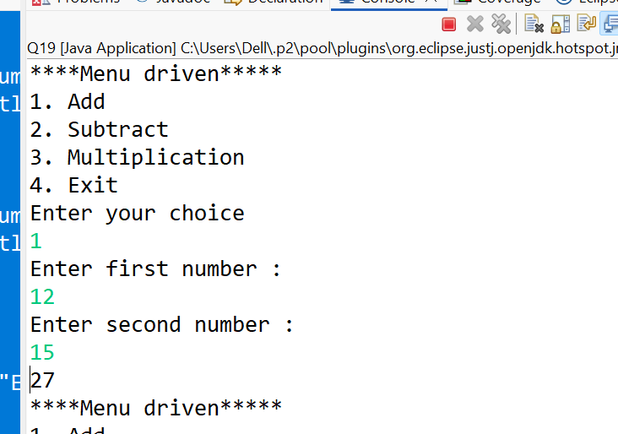

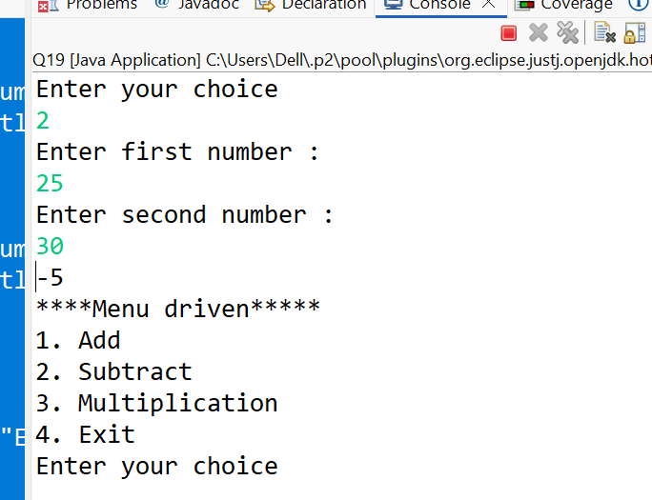
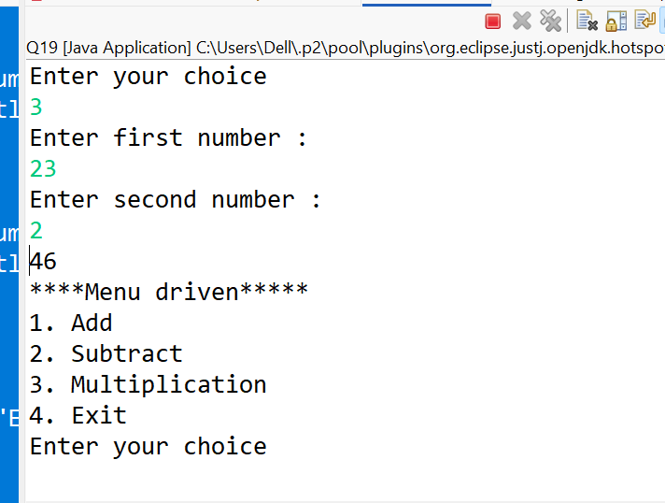
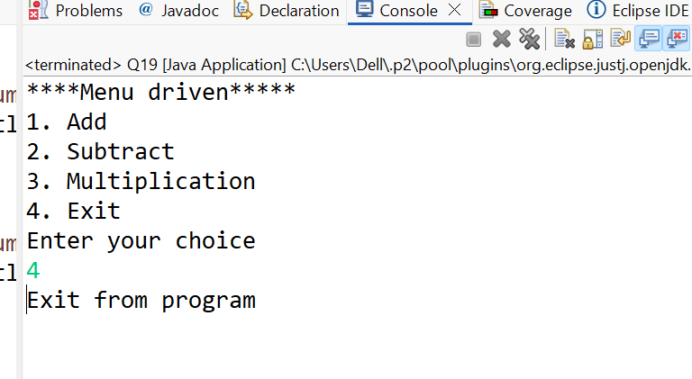

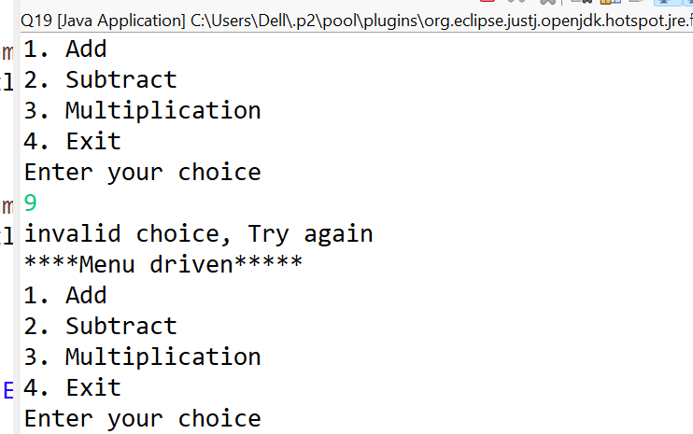

Q20.
package LoopingAssignment;

import java.util.Scanner;

public class Q20 {

public static void main(String[] args) {
System.out.println("Enter the number :");
Scanner sc=new Scanner(System.in);
int num=sc.nextInt();
int rev=0;
int r=num;
int d;
do
{

d=num % 10;
rev=rev*10+d;
num=num/10;

}while(num!=0);

if(r==rev)
{
System.out.println("Number is palidrome " +r);
}
else
{
System.out.println("Number is not palidrome " +r);
}
sc.close();
}

}
Output:
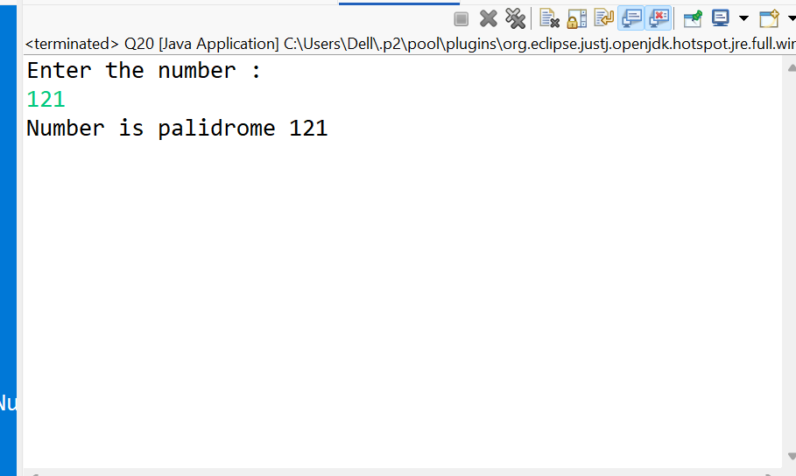
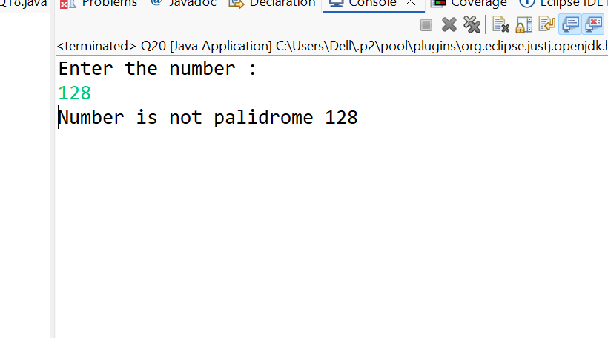
Q21
package LoopingAssignment;

public class Q21 {

public static void main(String[] args) {
for(int i=1;i<=500;i++)
{
int count=0;

for(int j=1;j<=i;j++)
{
if(i % j==0)
{
count++;
}
}
if(count==3)
{
System.out.println(i);
}
}

}

}
Output:
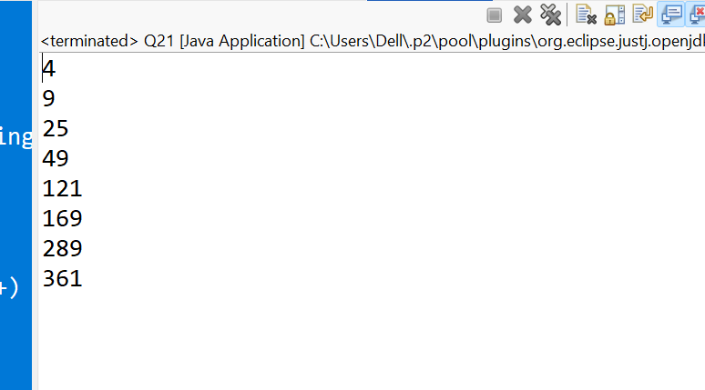

Q22.

package LoopingAssignment;

public class Q22 {

public static void main(String[] args) {
int largest=0;

for(int i=100;i<=1000;i++)
{
int num=i;
int rev=0;

for(int temp=num;temp!=0;)
{
int d= temp % 10;
rev=rev*10+d;
temp=temp/10;
}
if(i==rev)
{
if(i>largest)
{
largest=i;
}
}
}
System.out.println("largest palindrome number between 100 and 1000 is : " +largest);
}

}
Output:
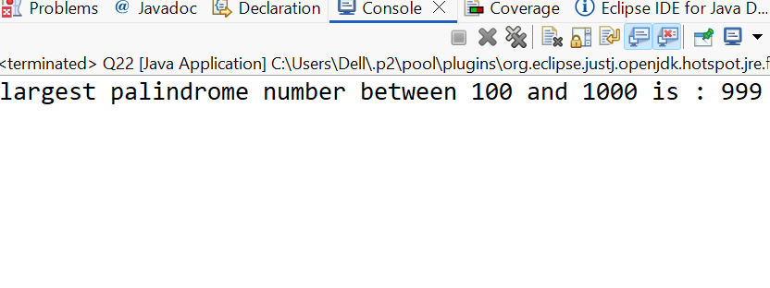

Q23
package LoopingAssignment;

public class Q23 {

public static void main(String[] args) {
for(int i=1;i<=5;i++)//i=1 1<=5 //2 2<=5
{
for(int j=1;j<=i;j++)//j=1 1<=1//2<=1f//2<=2f
{
if(j==3)
{
continue;
}
System.out.print(j);//1
}
System.out.println();//nextline
}
}

}
Output

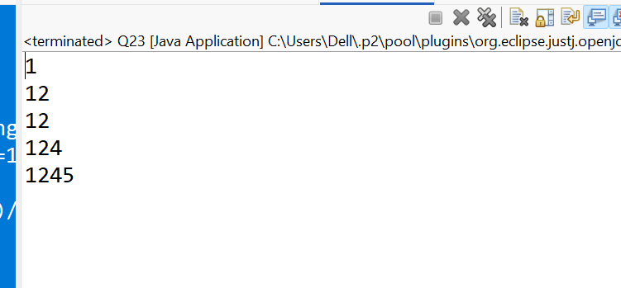

Q24
package LoopingAssignment;

public class Q24 {

public static void main(String[] args) {
for(int i=5;i>=1;i--)
{
for(int j=i;j>=1;j--)
{
System.out.print(j + " ");
}

System.out.println();
}

}

}

Output:
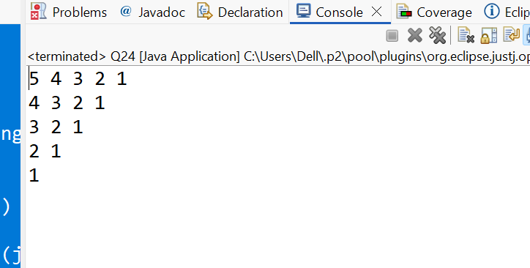

Q25:
package LoopingAssignment;

public class Q25 {

public static void main(String[] args) {

//perfect number is sum of the divisor is equal to same number
//ex: 6 divisors are 1,2,3 sum of theses divisors=6

System.out.println("Proper Perfect numbers between 1 to 1000 are : ");
for(int num=1;num<=10000;num++)
{
int sum=0;
for( int i=1;i<num;i++)
{
if(num % i==0)
{
sum += i;
}

}
if(sum==num)
{
System.out.println(num);
}
}
}

}
Output:
